YURT – Mongolian
7.2 mtrs diameter,
LAYERS - navy blue cotton internal wrap, YAKS Felt, silver insulation, exterior canvas cover (Needs replacing at £500)
Commercial carpet, Some furniture like 4 – 6 Futons, Bookcase and washstand.

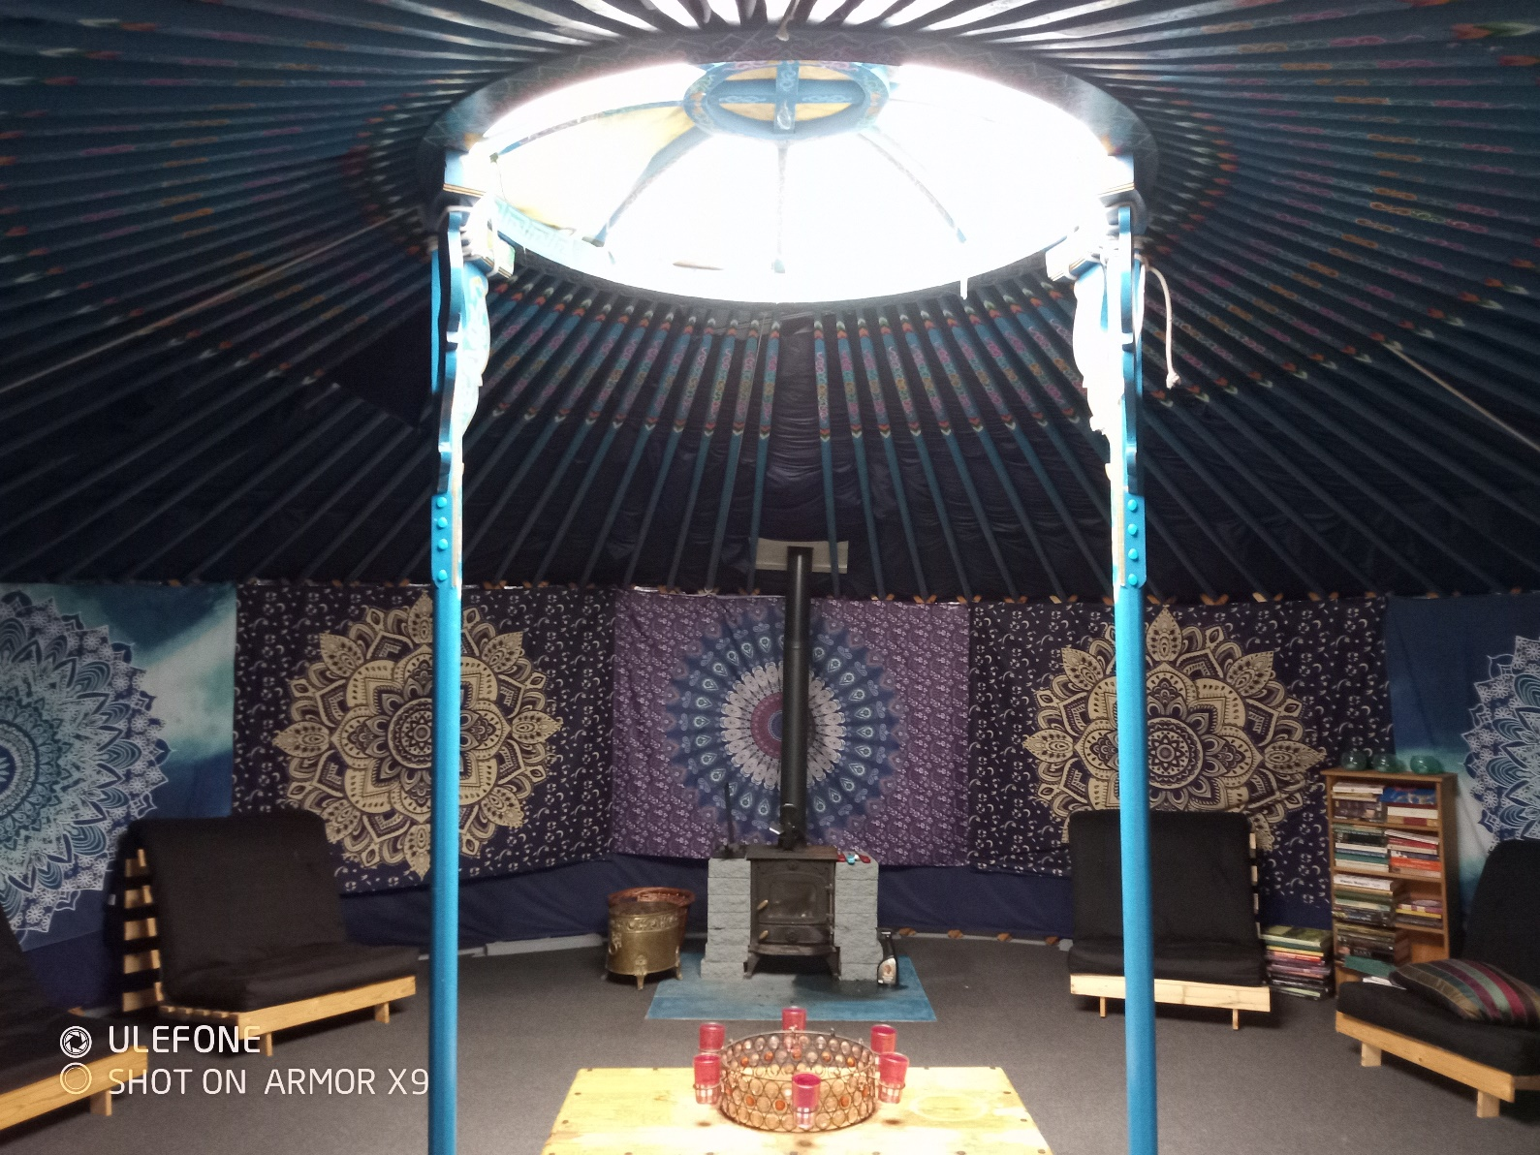

The wood burning stove has been removed. The cost to replace is £250 from Machine Mart

£5000

